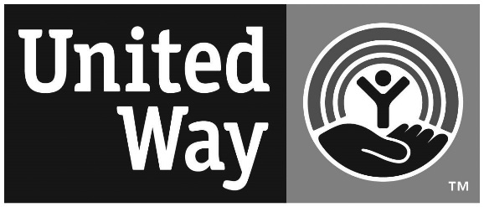

COMMUNITY FUND VOLUNTEER

INFORMATION SHEET

In order to ensure that the Community Fund Process is of the highest quality, we make an effort to place volunteers in committees where they have the most interest and/or expertise. Please select the areas below you feel would be most appropriate for you. IT IS NOT NECESSARY TO HAVE EXTENSIVE KNOWLEDGE IN AN AREA. Committees are purposely blended to include community members with a variety of backgrounds and interests.

Name

Address

Phone (home or cell) Work Phone

E-mail Address ________________________________________________________________

CHILD CARE (list experience and past or present affiliations)

MENTAL HEALTH (list experience and past or present affiliations)

_____HOUSING & EMERGENCY ASSISTANCE (list experience and past or present affiliations)

_____ LIFE SKILLS & LITERACY (list experience and past or present affiliations)

_____ PARENTING SKILLS (list experience and past or present affiliations)

_____SUBSTANCE ABUSE PREVENTION (list experience and past or present affiliations)

I am a board member, the spouse of a staff or board member, ex-staff member or volunteer with the following Community Fund agencies (visit www.ulsterunitedway.org for a complete list):

If there is any presently funded Community Fund agency that you feel you cannot objectively evaluate, please list it here (visit www.ulsterunitedway.org for a complete list):

E-MAIL OR MAIL YOUR COMPLETED APPLICATION TO: STACEY REIN AT STACEYREIN@ULSTERUNITEDWAY.ORG OR 450 ALBANY AVE., KINGSTON, NY 12401. If you should have any questions or need further information, please contact Stacey at the United Way, 331-4199, x1, or staceyrein@ulsterunitedway.org.

We look forward to working with you. THANK YOU!

